**Exercise 14: Online Bookstore – Integrating Testing for REST Services**

**Business Scenario:**

Write integration tests for your bookstore's RESTful services.

1. **Spring Test:**

* Done Set up Spring Test for integration testing by adding the spring boot starter test dependency in pom.xml file:

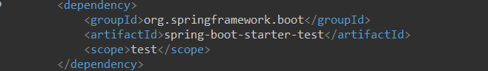

1. **MockMvc Integration:**

* Used MockMvc for end-to-end testing of your REST endpoints:

BookControllerTest.java:

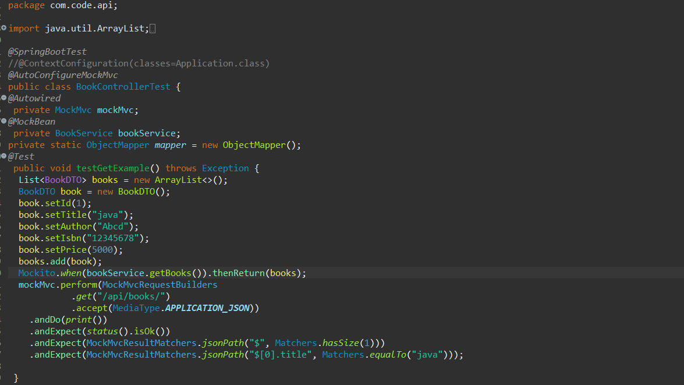

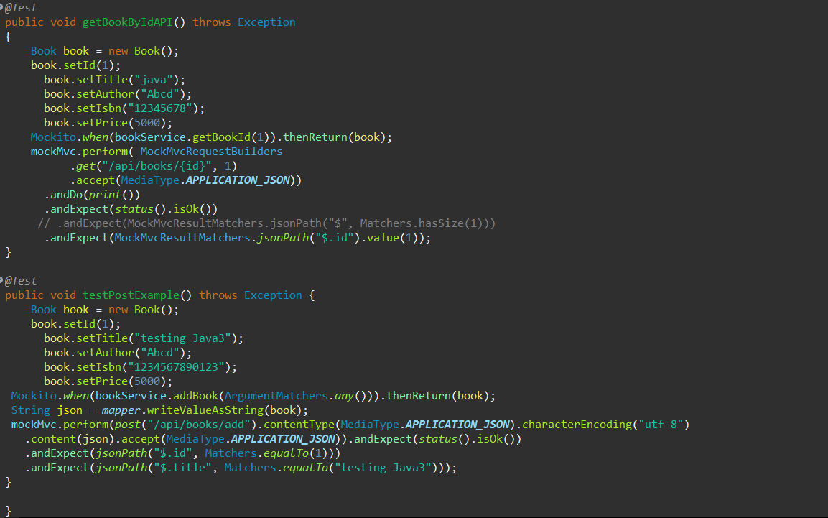

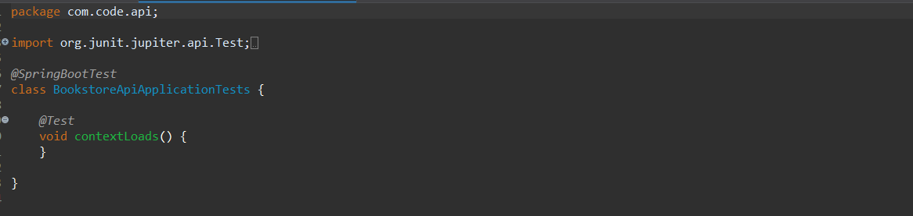

1. **Database Integration:**

* Include database integration in tests using an in-memory database like **H2**.

Configured an H2 in-memory database in the application-test.properties file for testing.

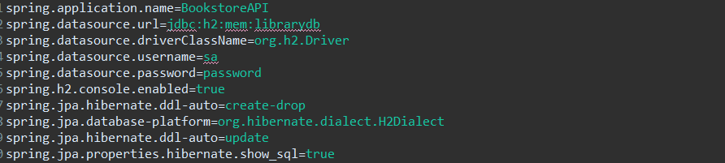

**Output:**

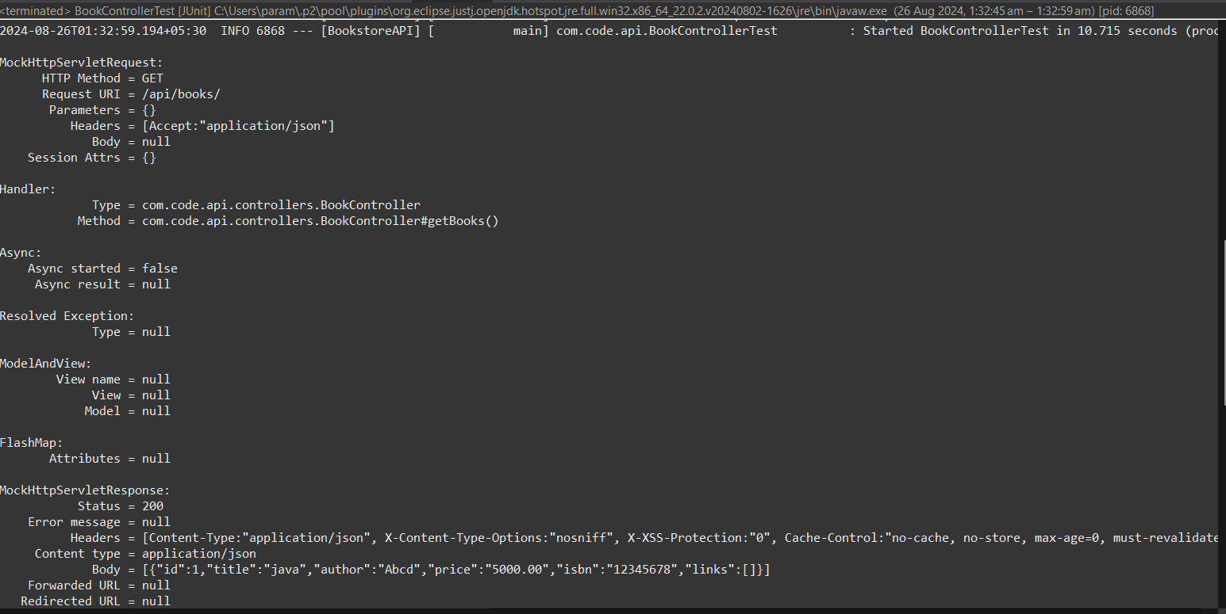

Status:

